|  |
| --- |
| Motivating employees |
| The relationship between employee and manager is important. **Not only can** it affect an employee's **morale**, but it can have wider consequences on the company **as a whole.** It's hard to imagine any company doing well without motivated employees. Here are five effective ways to motivate staff. |

* **Incentivize your employees**. Make them feel that the company's success means success for them as well. There's nothing like a possible reward to motivate people. A program like this will probably have to come from upper management, not just from the direct manager.
* Take an active interest in your employees' career paths. Offer them additional training and act as their mentor. If employees feel that **a brighter future/prospect/outlook is ahead**, they will be more productive/**prolific**.
* Emphasize a healthy work-life balance. Recognizing that an employee has a life outside the company, and allowing some flexibility in the schedule, can make a big difference in developing a positive attitude.
* Listen to your employees. If people feel like they are being heard, even when they are complaining, they will be happier and more productive.
* Treat **subordinates** the way you would like to be treated by your superiors. Respect for others goes a long way. Never treat your subordinates in a condescending manner居高临下的.

Here are five **surefire** 准不会有错的 ways to **demotivate** your staff. It goes without saying that the following kinds of behavior are not recommended.

* Use your **managerial**[mænə'dʒiːrɪəl] position to show people who's boss. Disrespect subordinates because they are below you.
* Take credit or claim responsibility for work done by your subordinates. They work for you, right? So why give them credit?
* Lose your temper, being **grumpy**. Getting angry always shows people who's boss!
* Let employees unfairly take the blame for things. Better them than you, right?
* Don't compliment or praise people for good work. The next thing you know, they'll want a promotion or pay raise!

//take credit for  因…得到好评

# Successfully motivating employees

A team of employees in your company has been **left demoralized (morale)** by their previous manager, who never listened to them and showed them no respect. You're helping to hire the new manager. You want to find someone who listens and can also motivate

# **Traits** of successful people**成功人士的特征**

以下是一些谈论成功的表达

|  |  |
| --- | --- |
| **What manner/type of success** are you looking for exactly? | 你具体希望获得哪种成功？ |
| **It's difficult to pinpoint what defines** success. | 很难准确描述什么是成功。 |
| He was able to **turn his academic success into business success**.  Part of my success **comes down to** xxx | 他做到了将优秀的学习成绩转化成商业上的的成功。 |

以下是谈论成功人士的特征traits的词汇

## e.g Venus Williams’s traits

|  |  |  |  |
| --- | --- | --- | --- |
| It's not easy to **pinpoint** what **traits** make people successful. | | 要确定让人取得成功的特点并不容易。 | |
| She's very **resilient.** She's always able to **bounce back from adversity**. **//Venus William**  She (Venus Williams) bounces back from **adversity/ədˈvɜːsɪtɪ//predicament/plight**. She's very **resilient**. | | 她非常**达观**，总能从逆境中恢复过来。 | |
| No matter what happens, he never gives up. He's very **persistent**, and **perseverant**.  //Venus Williams | | 不管怎么样，他从不放弃。他非常执著。 | |
| She's incredibly **passionate** about her work. // //Venus Williams | |  | |
|  | | |
| **e.g. Steve Job’s traits**  **one of the most successful person’s traits.** Steve Jobs was one of the most **innovative** thinkers of his time.  They're very **proactive**. They try to anticipate problems before they happen. | 他们行事主动，努力未雨绸缪。 | | | |
| **Creativity** is very important, but so are **practical, hands-on (real-world)** business skills. | 创造力非常重要，但**实用的**商务技能同样重要。 | | | |
| He has a great ability to find **pragmatic** solutions to problems. | **他拥有为问题找出 切实可行/务实的 办法的出色能力。** | | | |
|  |  | | | |

 It's not easy to define which **traits** make someone successful.  
  
She never gives up. She's very **persistent坚持的** and **perseverant 坚持不懈的，坚忍不拔**.  
  
He was able to **pinpoint** the problem.  
  
Don't wait for problems. Be **proactive** and plan ahead.  
  
He's so **innovative**, always coming up with great new ideas, eps **pragmatic**务实的切实可行 idea.

篇章是如何组织的？  
  
**Chronological:** 时间顺序  
**Compare and contrast:** 两件或两件以上事情的相同点和不同点  
**Positive and negative:** 一种情况或事情的优点和缺点  
**Sequence:** 发生顺序，适合描写指示、说明或过程  
**Cause and effect:** 解释某事的结果或发生的原因  
**List:** 一系列列出的事项，或按实际的表格进行呈现，或按顺序在段落中进行介绍。  
**Problem and solution:** 找出问题和可能的解决办法  
**Spatial:** 描述某物的外观，也称 **descriptive**  
**Order of importance:** 重要性从高到低，或从低到高

# What kind of person becomes a success?

The truth is, there's no easy answer to this question. You can focus on certain **personality traits**特征, like being a good listener or having lots of creativity, but what is it exactly that makes very successful people so different from the rest of us?

One thing seems clear: Successful people are **passionate** people, well sort of **vibrant and exuberant** (full of life, energy, and enthusiasm. 充满活力的). It might be that someone is passionate about money, someone else might be passionate about helping others, but the type of motivation isn't all that important. The important lesson here is that successful people have an objective, a target, an idea or a dream that they work toward and feel passionate about. They're not just thinking about today; they're not just thinking about tomorrow; **they're thinking about the rest of their lives, and who they want to be.**

Successful people **prioritize their lives to reach their goals**, spending their time on what's important for achieving their dreams. This focus can have negative effects. Focusing solely on one important thing can lead to you losing focus on other things, like family, relationships, a social life and hobbies. And if things go wrong in the one thing you're focusing on, then what's left? **To be brutally honest,** there's nothing left. This is the chance many successful people take. Their very drive can cause them to risk everything that they have.

Of course, not everyone has this drive, and not everyone can be successful. While rich, successful people live in gated **lavish**  盛大奢华的communities, drive flashy cars and eat in the best restaurants, **conversely**, a far greater number of people do not enjoy these luxuries. **It's a coin with two sides: success and failure; rich and poor; lucky and unlucky**. One can't exist without the other. However, is it fair that a small minority of people have all the wealth and, therefore, all the power? Probably not. But that's why we want to be successful: It allows us luxuries that others do not have.

So, how do you become successful? Most important, you have to **find your passion**. Think about what it is that you really want to do with your life, and **go for it**. Once you know what you want, stay focused. Don't let anything or anyone becomes barricades in your way. Don't take 'no' for an answer or let failure or mistakes along the way stop you from realizing your objective. It's your life and your dream, be it big or small. And don't forget: **Enjoy the ride = enjoy your life! Life is not a rehearsal; life is so short. Try to maximize it. The most important is to enjoy it. Enjoy the ride.**

**//It’s an incredible ride through my life**

# Writing about successful people's habits

Write about the traits特征 and habits of a successful person you admire （e.g. Oral topic:　Ｖｅｎｕｓ　Ｗｉｌｌｉａｍｓ/ Kobe ）. He or she does not have to be well-known. If you prefer, you can discuss the topic in more general terms.

**=> Consider SWOT: strength V.S. weakness; Opportunity V.S. threat (like a coin with two side, pros and cons; advantages V.S. downsides)**

## Ｓａｍｐｌｅ

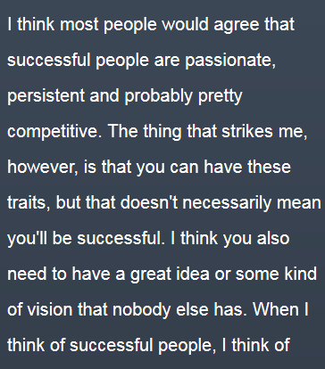 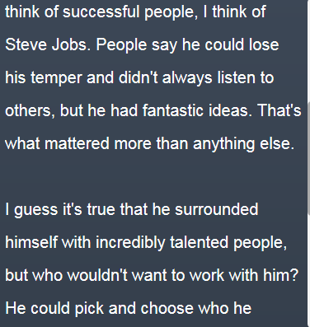 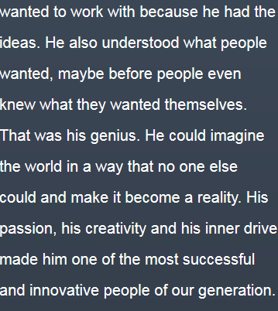

Successful person – Venus Williams

I’m full of admiration for Venus Williams, who has become the Australian Open's oldest female grand slam winner. Obviously, she's a very successful person. The most impressive thing that strikes me is that she is such a persistent person who insists her tennis career for almost three decades, which is an amazing record. I guess if she doesn't have considerably passion in tennis, she wouldn't get high achievement today. I have to mention that several years ago, she was diagnosed with an eye-related syndrome that causes side effects, such as fatigue. It's incredible to think how she overcame pains and keep doing exercise during that grueling time. From my perspective, part of her success comes down to her perseverant fight and unwavering winning belief. She always has a resolute winning believe on herself. In a nutshell, her insistence, her resilient ability to afford the bounce back from the predicament, and her strong passion on tennis all drive her to become one of the most successful people in the world.